Right_Tringle pattern1

*

* *

* * *

* * * *

#!/bin/bash

read -p "Enter the number : " num

for(( i=1; i<=num; i++))

do

for(( j=1; j<=i; j++))

do

echo -n "*"

done

echo " "

done

======================================

Right Reverse Tringle pattern2

* * * *

* * *

* *

*  
read -p "Enter the number : " num

for(( i=num; i>=1; i-- ))  
  
do  
  
for((j=1; j<=i; j++))  
  
do  
  
echo -n "*"  
  
done  
  
echo " "  
  
done

==================================================

Left Tringle pattern3

*

* *

* * *

* * * *

read -p "Enter the number : " num

for((i=1; i<=num; i++))  
  
do  
  
for((k=1; k<=(num-i); k++))  
  
do  
  
echo -n " "  
  
done  
  
for((j=1; j<=i; j++))  
  
do  
  
echo -n "*"  
  
done  
  
echo  
done

===============================================

Left Reverse Tringle pattern4

* * * * *
* * * *
* * *

*  
read -p "Enter the number : " num  
  
for((i=1;i<=num;i++))  
  
do  
  
for((k=1;k<i;k++))  
  
do  
  
echo -n " "  
  
done  
  
for((j=1;j<=num-i+1;j++))  
  
do  
  
echo -n "*"  
  
done  
  
echo " "  
  
done

====================================================

Half upper pyramid pattern5

* *
* * *
* * * *
* * * * *  
    
  read num  
    
  for((i=1;i<=num;i++))  
    
  do  
    
  for((k=1; k<=num-i; k++))  
    
  do  
    
  echo -n " "  
  done  
    
  for((j=1;j<=I; j++))  
    
  do  
    
  echo -n "* "  
  done  
    
  echo " "  
    
  done

================================================

Half Reverse Pyramid pattern6

* * * * * *
* * * * *
* * * *
* * *
* *  
  read num  
    
  for((i=1;i<=num;i++))  
    
  do  
    
  for((k=1;k<i;k++))  
    
  do  
    
  echo -n " "  
    
  done  
    
  for((j=1;j<=num-i+1;j++))  
    
  do  
    
  echo -n "* "  
    
  done  
    
  echo " "  
    
  done

Q.2 Create Numbers.txt which will contain numbers from 1-50

a. display first 15 numbers

b. display last 10 numbers

c. display numbers in reverse order.

d.display numbers which includes 4 in it

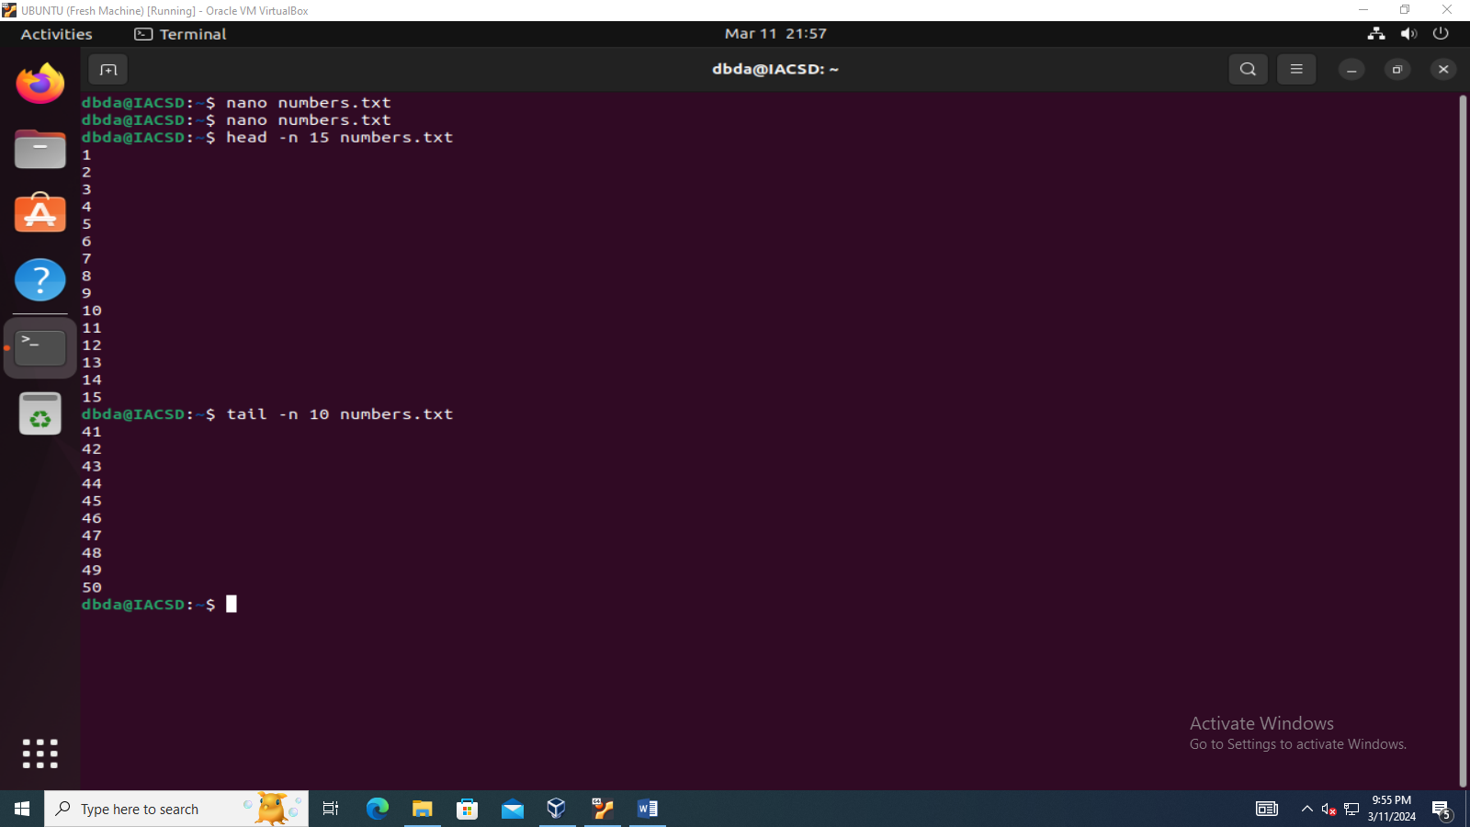

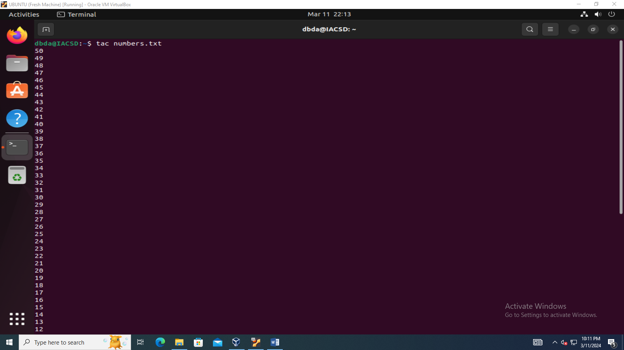

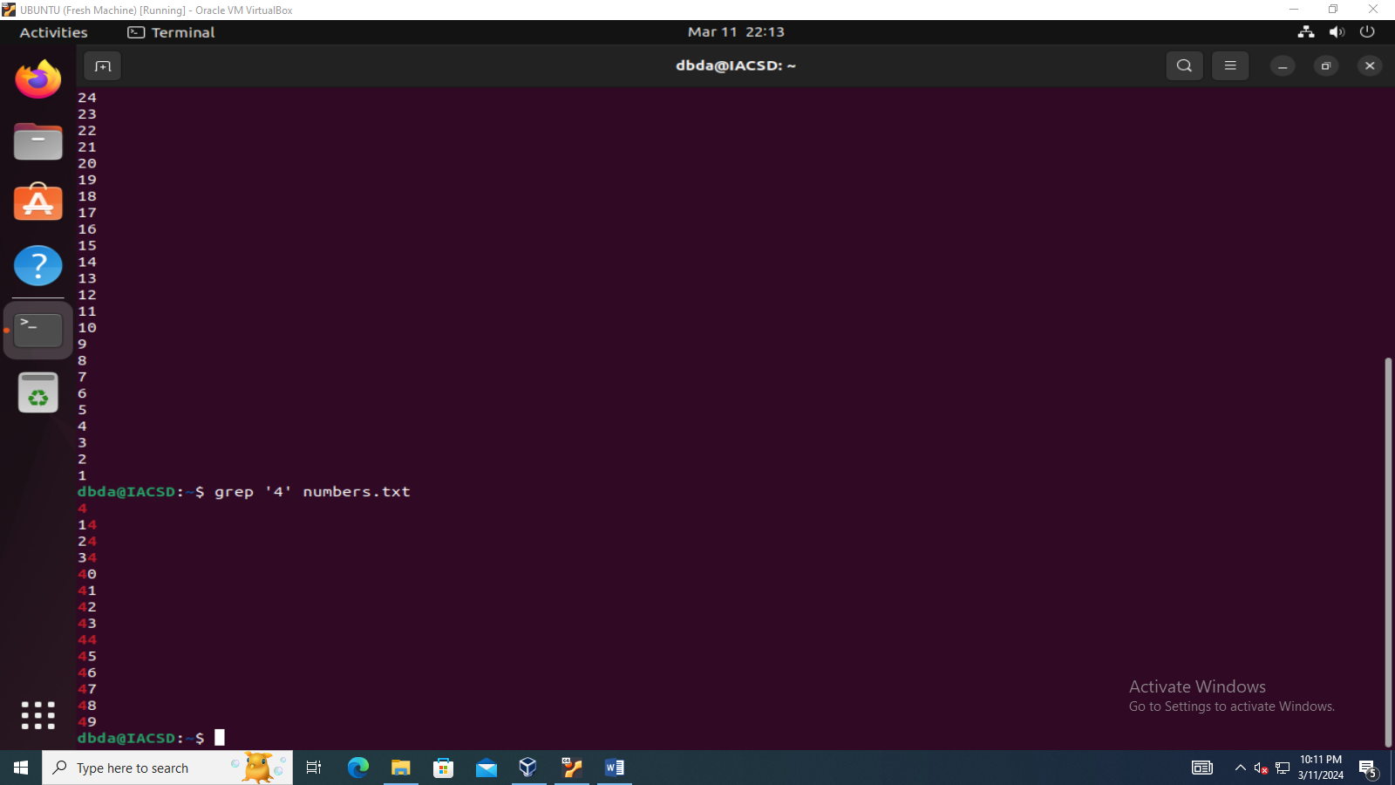

Q.3 create Student.txt file as given below

Rollno:name:marks

1111:Ram:87

2222:Sham:69

3333:Teena:58

4444:Priya:74

1. Display only details of sham
2. Display only marks of Priya
3. Display total number of lines in student.txt

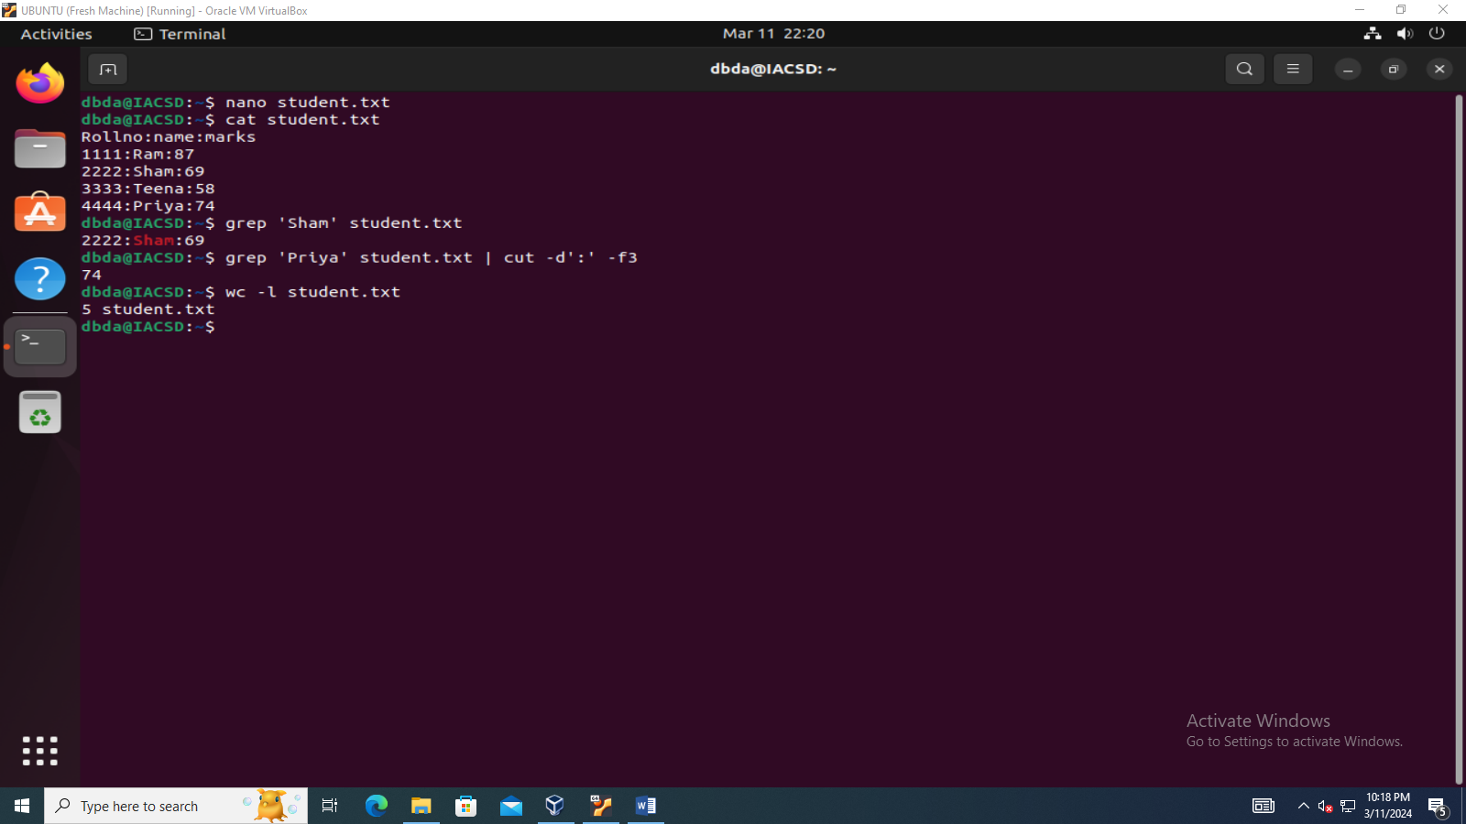

1. Write a Shell Script to find maximum between two numbers.

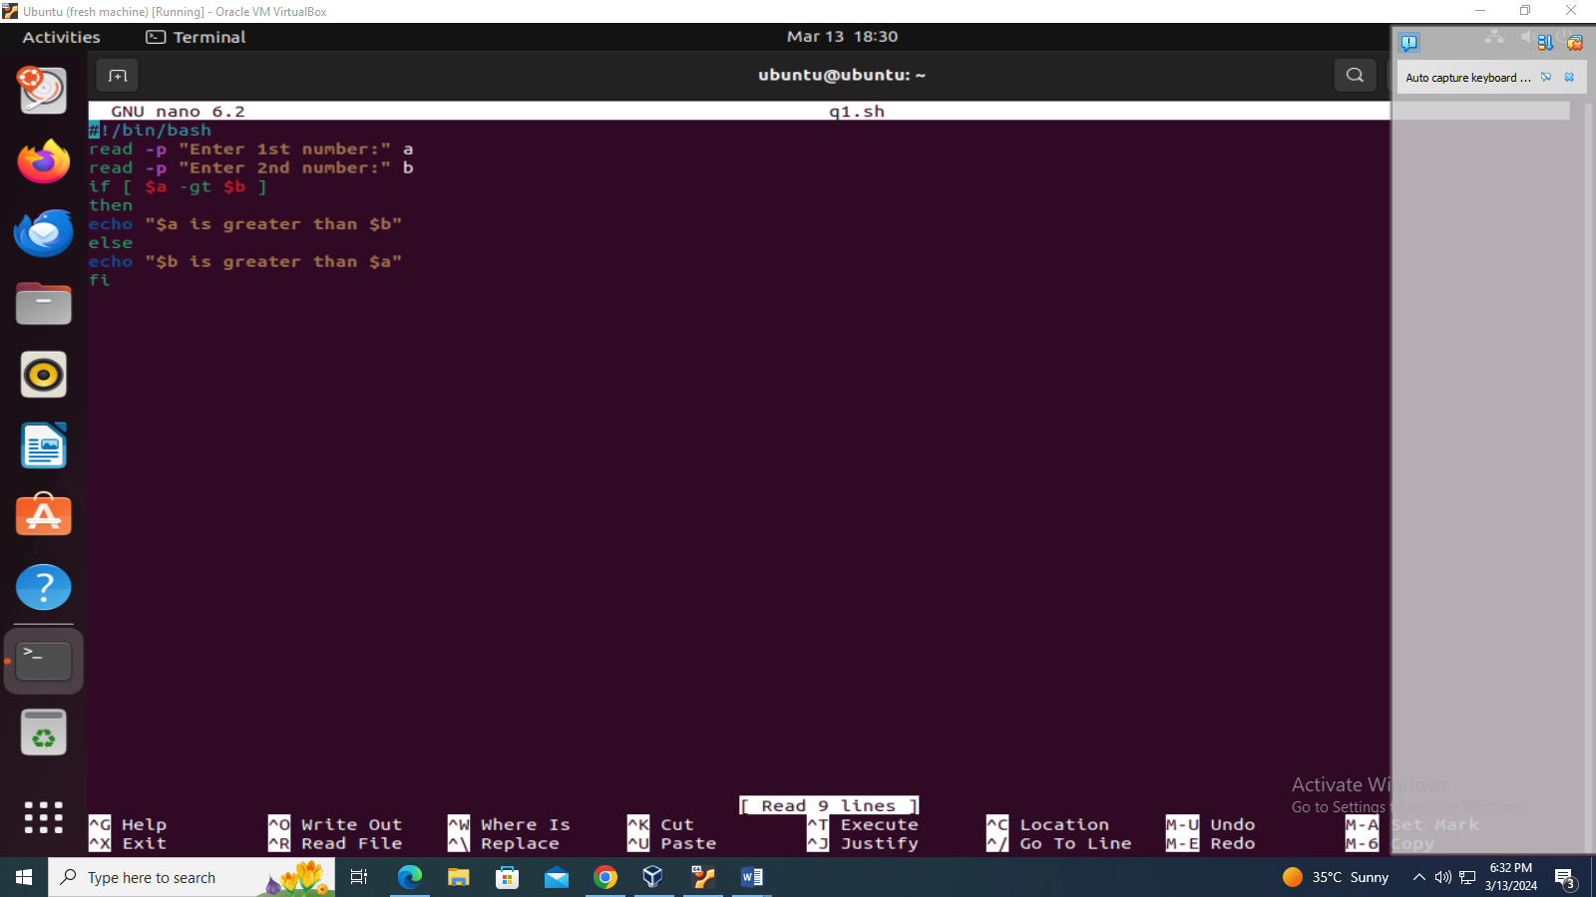

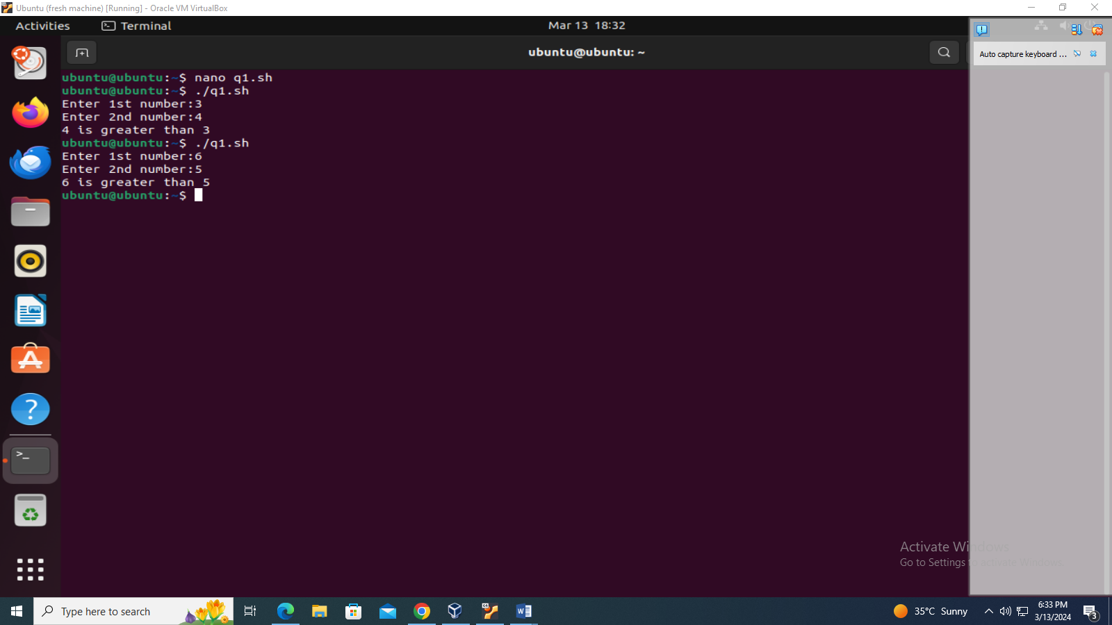

2.Write a Shell Script to find maximum between three numbers.

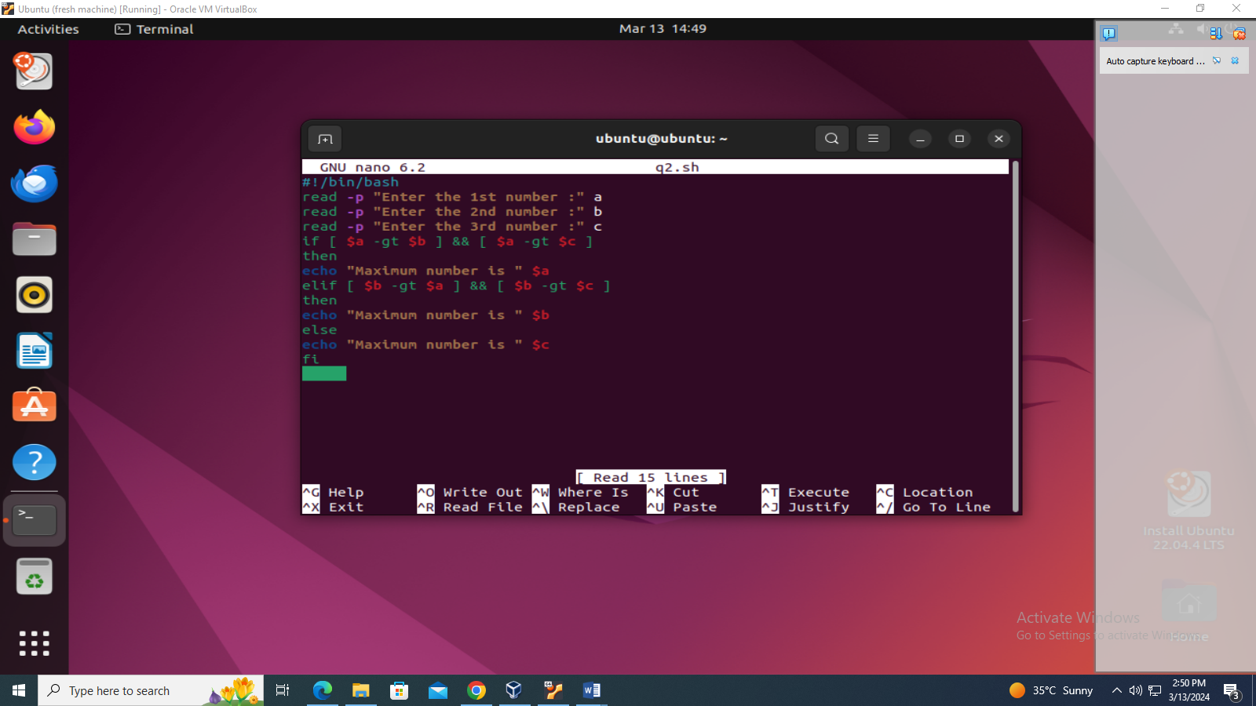

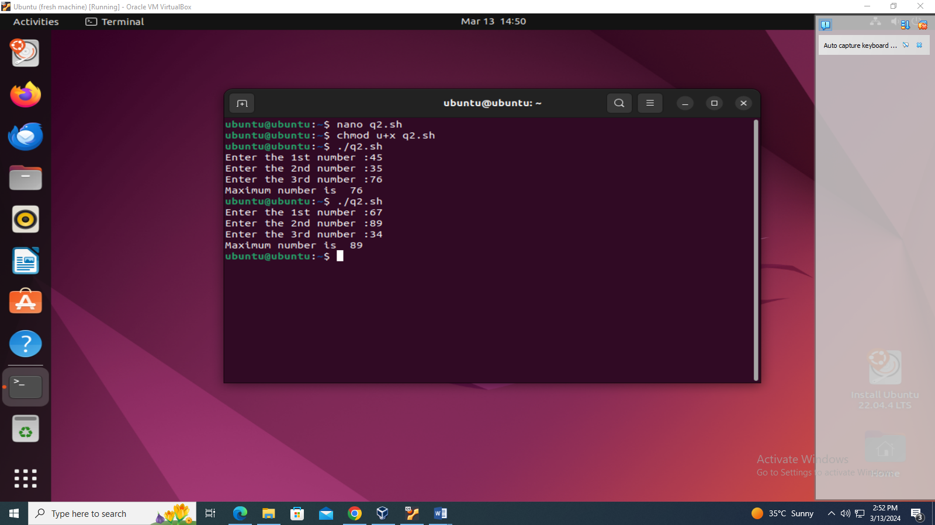

3.Write a Shell Script to check whether a number is negative, positive or zero.

